# SWA Review Document

## Initial Review for Architectural Document

|  |  |
| --- | --- |
| **Date** | 21-1-2021 |
| **Effort** | 1 hours |
| **Room/Location** | Google Meets |
| **Review Status** | Open |
| **Review name** | SWA_template.docx |
| **Method** | WT |
| **Release** | R2 |
| **Responsible** | Carlos Diaz |
| **Project** | Door Control Module |
| **Reason of Review** | Initial Release of Arch. |

## Update Architectural Document

|  |  |
| --- | --- |
| **Date** | 22-01-2021 |
| **Effort** |  |
| **Room/Location** |  |
| **Review Status** | Closed |
| **Review name** | SWA_template.docx |
| **Method** | WT |
| **Release** | R2.1 |
| **Responsible** | No Final Review because at Friday January 22, 2021 at 6:35 pm, no peer has reply to the review request. |
| **Project** | Door Control Module |
| **Reason of Review** | Fix open comments from previous review. |

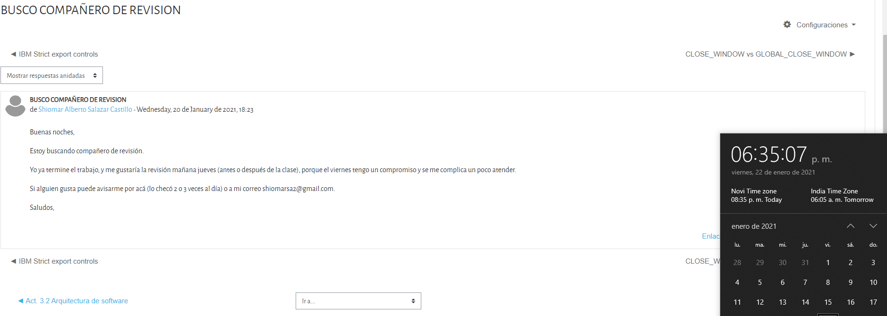

## Comment List

|  |  |  |  |  |  |
| --- | --- | --- | --- | --- | --- |
| **No.** | **Reference** | **Comments / Actions** | **Classification (E)rror/Risk / (R)emark** | **Responsible person/Planned date for completion** | **Completion(Name/Date)** |
| 1 |  | Revisar el Checklist antes de la sesión. | Remark |  |  |
| 2 |  | Agregar Diagrama de Secuencia Funcional y Físico en el Door Locking. | Error | Shiomar Salazar / 2021-01-22 | Shiomar S. / 22-01-2021 |
| 3 |  | Agregar al MCU_Layer el SWC de CAN. | Error | Shiomar Salazar / 2021-01-22 | Shiomar S. / 22-01-2021 |
| 4 |  | Falta incluir API a tabla 5.3. | Error | Shiomar Salazar / 2021-01-22 | Shiomar S. / 22-01-2021 |
| 5 |  | Checar errores ortográficos. | Error | Shiomar Salazar / 2021-01-22 | Shiomar S. / 22-01-2021 |
| 6 |  | CanManager consume variante y agregar DCM_1 y DCM_2 a la interfaz. | Error | Shiomar Salazar / 2021-01-22 | Shiomar S. / 22-01-2021 |
| 7 |  | Agregar Datos a la Secuencia Física, valores de los argumentos. | Error | Shiomar Salazar / 2021-01-22 | Shiomar S. / 22-01-2021 |
| 8 |  | Terminar pasos de Integración. | Error | Shiomar Salazar / 2021-01-22 | Shiomar S. / 22-01-2021 |
| 9 |  | Re trabajar Trazabilidad para poner solo elementos SWC físicos. | Error | Shiomar Salazar / 2021-01-22 | Shiomar S. / 22-01-2021 |

## Check List

|  |  |  |  |  |  |
| --- | --- | --- | --- | --- | --- |
| No | Description | OK / NOK / NR | Comment | Responsible person /  Planned date for completion | Status |
| 1 | Does the design comply to the SW Requirements? | OK |  |  | Closed |
| 2 | Are all requirements allocated to Architectural elements? | OK |  |  | Closed |
| 3 | Is the system context (environment) of the software architecture described? | OK |  |  | Closed |
| 4 | Is a global overview of all SW function blocks (Functional Architecture) and SW components (Physical Architecture) provided, giving the reader a good understanding of the overall dependencies? | OK |  |  | Closed |
| 5 | Are the functions identified from SW requirements and reviewed there are no missing functions? | OK |  |  | Closed |
| 6 | Are the functional interfaces documented? | OK |  |  | Closed |
| 7 | Is each SW function mapped to one or more SW components? I.e. is there a mapping from functional to physical software architecture? | OK |  |  | Closed |
| 8 | Do SW components' interfaces export only the needed data and functions (encapsulation principle)? If not, are the reasons given? | OK |  |  | Closed |
| 9 | Are diagrams (e.g. use case charts, sequence charts…) used were appropriate? | OK |  |  | Closed |
| 10 | Are the SW components identified? | OK |  |  | Closed |
| 11 | Are the Physical Interfaces identified with a clear usage description? | OK |  |  | Closed |
| 12 | Are the OS task properly defined and documented? | OK |  |  | Closed |
| 13 | Are the Interrupt usage described? | OK |  |  | Closed |
| 14 | Are there Power Modes identified and documented? | NR |  |  | Closed |
| 15 | Is the integration Plan properly described with the corresponding order for the software construction order? | OK |  |  | Closed |
| 16 | Is the functional safety information properly described on the SWA document? | NOK |  |  |  |